**Responsive Design**

Learn how to make your web designs adapt to different screen sizes and devices using **media queries** and **fluid layouts**.

**Responsive Design** in CSS is an approach to web design that ensures web pages render well on a variety of devices and window or screen sizes.

It aims to provide an optimal viewing and interaction experience—easy reading and navigation with a minimum of resizing, panning, and scrolling—across a wide range of devices, from desktop computers to mobile phones.

Here are the key principles and techniques of Responsive Design in CSS:

**1. Fluid Grids**

* **Definition**: Use relative units like percentages instead of absolute units like pixels to define the widths of elements.
* **Example**: Instead of setting an element's width to 960px, you might set it to 80%.

.container {

width: 80%;

}

**2. Flexible Images**

* **Definition**: Ensure images scale within the context of their containing elements by using relative units and CSS properties like max-width.
* **Example**: Setting an image's max-width to 100% ensures it scales down if necessary, but not up beyond its original size.

img {

max-width: 100%;

height: auto;

}

**3. Media Queries**

* **Definition**: Use CSS media queries to apply different styles for different screen sizes and resolutions.
* **Example**: Change the layout for devices with a width less than 600px.

@media (max-width: 600px) {

.container {

width: 100%;

}

}

**4. Responsive Typography**

* **Definition**: Use relative units like em (relative to parent) or rem (relative to the root (html)) for font sizes to ensure text scales appropriately.
* **Example**: Setting a base font size and adjusting it with media queries.

body {

font-size: 16px;

}

@media (max-width: 600px) {

body {

font-size: 14px;

}

}

**5. Responsive Navigation**

* **Definition**: Adjust navigation menus for different screen sizes, often switching from horizontal menus to dropdowns or other mobile-friendly formats.
* **Example**: Using a hamburger menu on smaller screens.

<nav>

<div class="menu-icon" onclick="toggleMenu()">☰</div>

<ul class="nav-list">

<li><a href="#">Home</a></li>

<li><a href="#">About</a></li>

<li><a href="#">Services</a></li>

<li><a href="#">Contact</a></li>

</ul>

</nav>

.nav-list {

display: flex;

justify-content: space-around;

}

@media (max-width: 600px) {

.nav-list {

display: none;

flex-direction: column;

}

.menu-icon {

display: block;

}

}

.menu-icon {

display: none;

cursor: pointer;

}

function toggleMenu() {

var navList = document.querySelector('.nav-list');

if (navList.style.display === "block") {

navList.style.display = "none";

} else {

navList.style.display = "block";

}

}

**6. Viewport Meta Tag**

* **Definition**: Use the viewport meta tag to control the layout on mobile browsers.
* **Example**: Setting the viewport to the device’s width and initial scale.

**<meta name="viewport" content="width=device-width, initial-scale=1.0">**

**Summary**

Responsive Design in CSS involves the use of fluid grids, flexible images, media queries, responsive typography, and other techniques to create web pages that adapt to different devices and screen sizes. This approach ensures that users have a consistent and optimal experience regardless of the device they use.

**Media Query**

A media query in CSS is a technique used to apply different styles to different devices and screen sizes.

Media queries enable responsive design by allowing you to specify CSS rules that apply only under certain conditions, such as minimum or maximum width, screen orientation, resolution, and other media features.

This allows a website to adapt its layout and design based on the characteristics of the user's device.

**Basic Syntax**

The basic syntax for a media query includes the **@media** rule, followed by a media type and one or more media features.

The styles within the curly braces {} are applied only if the media query conditions are met.

@media media-type and (media-feature: value) {

/* CSS rules go here */

}

**Example: Applying Styles for Different Screen Sizes**

Here's an example where different styles are applied based on the screen width.

/* Styles for screens wider than 600px */

@media (min-width: 600px) {

body {

background-color: lightblue;

}

}

/* Styles for screens 600px or narrower */

@media (max-width: 600px) {

body {

background-color: lightgreen;

}

}

In this example:

* The first media query applies styles to screens that are at least 600 pixels wide.
* The second media query applies styles to screens that are 600 pixels wide or narrower.

**Common Use Cases**

1. **Adjusting Layout for Different Screen Sizes**

@media (max-width: 768px) {

.sidebar {

display: none;

}

}

This hides the sidebar on screens that are 768 pixels wide or narrower.

1. **Optimizing Typography**

@media (max-width: 600px) {

body {

font-size: 14px;

}

}

This changes the font size for smaller screens to improve readability.

1. **Handling Different Screen Orientations**

@media (orientation: landscape) {

.container {

width: 70%;

}

}

@media (orientation: portrait) {

.container {

width: 90%;

}

}

This adjusts the container width based on whether the screen is in landscape or portrait orientation.

**Combining Media Features**

You can combine multiple media features using and, or, and not operators.

/* Styles for screens between 600px and 1200px wide */

@media (min-width: 600px) and (max-width: 1200px) {

.content {

font-size: 18px;

}

}

/* Styles for screens wider than 1200px */

@media (min-width: 1200px) {

.content {

font-size: 20px;

}

}

**Targeting Specific Devices**

You can target specific devices using media types like screen, print, all, etc.

/* Styles for printing */

@media print {

body {

font-size: 12pt;

color: black;

}

}

**Example 01**

**Practical Example: Responsive Grid**

Here's a practical example of a responsive grid layout that changes based on screen size:

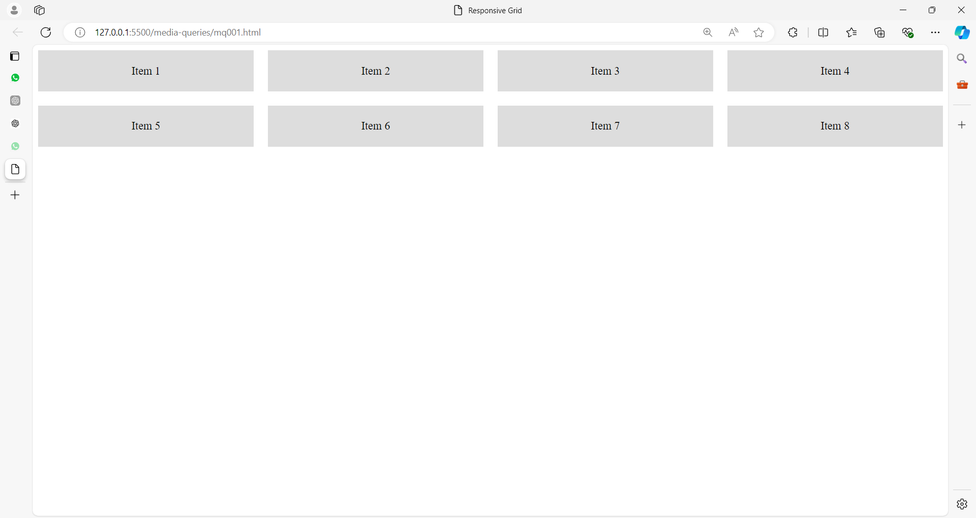

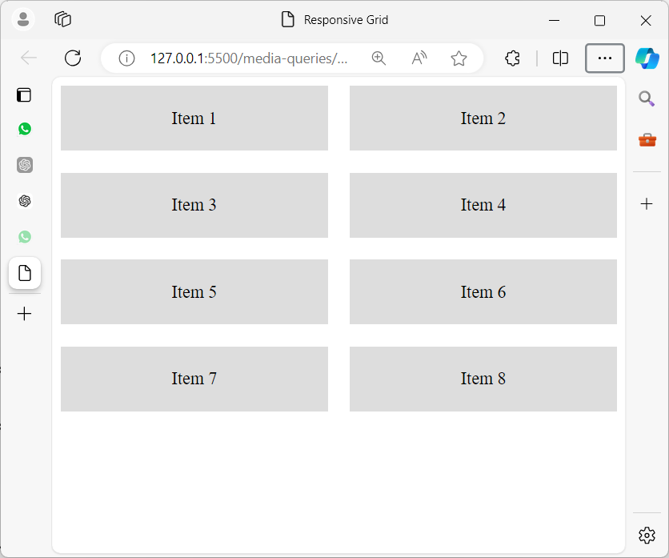

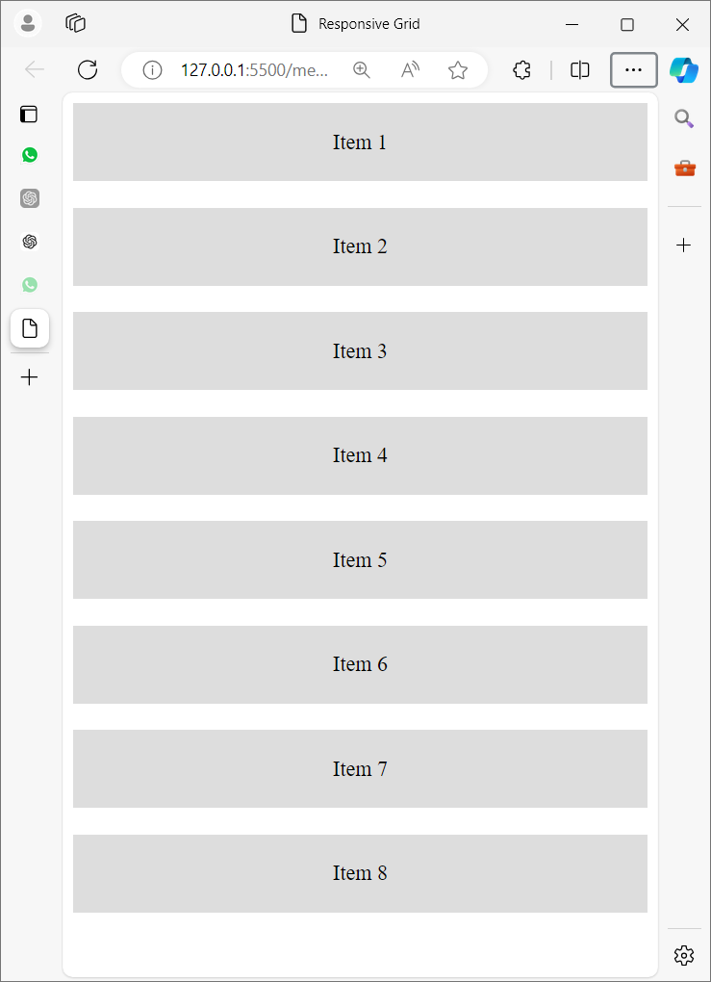

<!DOCTYPE html>

<html lang="en">

<head>

<meta charset="UTF-8">

<meta name="viewport" content="width=device-width, initial-scale=1.0">

<title>Responsive Grid</title>

<style>

.container {

display: grid;

grid-template-columns: repeat(4, 1fr);

gap: 20px;

}

@media (max-width: 1200px) {

.container {

grid-template-columns: repeat(3, 1fr);

}

}

@media (max-width: 768px) {

.container {

grid-template-columns: repeat(2, 1fr);

}

}

@media (max-width: 480px) {

.container {

grid-template-columns: 1fr;

}

}

.item {

background-color: #ddd;

padding: 20px;

text-align: center;

}

</style>

</head>

<body>

<div class="container">

<div class="item">Item 1</div>

<div class="item">Item 2</div>

<div class="item">Item 3</div>

<div class="item">Item 4</div>

<div class="item">Item 5</div>

<div class="item">Item 6</div>

<div class="item">Item 7</div>

<div class="item">Item 8</div>

</div>

</body>

</html>

Let's break down the provided CSS step by step:

**.container {**

**display: grid;**

**grid-template-columns: repeat(4, 1fr);**

**gap: 20px;**

**}**

* .container {}: This is targeting the HTML element with the class container.
* display: grid;: This sets the container to use CSS Grid Layout, which allows you to create a flexible grid of items.
* grid-template-columns: repeat(4, 1fr);: This defines a grid with 4 equal columns. The 1fr means that each column takes up one fraction of the available space.
* gap: 20px;: This sets a 20px gap (space) between the grid items (both horizontally and vertically).

**@media (max-width: 1200px) {**

**.container {**

**grid-template-columns: repeat(3, 1fr);**

**}**

**}**

* @media (max-width: 1200px) {}: This is a media query that applies styles only when the screen width is 1200 pixels or less.
* Inside this media query, it changes the grid for .container:
  + grid-template-columns: repeat(3, 1fr);: This adjusts the grid to have 3 equal columns instead of 4 when the screen width is smaller than 1200px.

**@media (max-width: 768px) {**

**.container {**

**grid-template-columns: repeat(2, 1fr);**

**}**

**}**

* @media (max-width: 768px) {}: This media query applies styles when the screen width is 768 pixels or less (typically for tablets).
* grid-template-columns: repeat(2, 1fr);: This reduces the grid to 2 equal columns when the screen width is smaller than 768px.

**@media (max-width: 480px) {**

**.container {**

**grid-template-columns: 1fr;**

**}**

**}**

* @media (max-width: 480px) {}: This media query applies styles when the screen width is 480 pixels or less (usually for mobile devices).
* grid-template-columns: 1fr;: This changes the layout to a single-column grid (each item takes the full width of the container) when the screen width is smaller than 480px.

**.item {**

**background-color: #ddd;**

**padding: 20px;**

**text-align: center;**

**}**

* .item {}: Targets elements with the class item.
* background-color: #ddd;: Sets the background color of each item to a light gray (#ddd).
* padding: 20px;: Adds 20px of padding inside each item (space between the content and the border of the item).
* text-align: center;: Aligns the text inside each item to the center.

**Summary:**

* The .container class creates a grid layout that adjusts the number of columns based on the screen size (4 columns on large screens, 3 columns on medium, 2 on tablets, and 1 on mobile).
* The .item class styles the individual grid items with padding, background color, and centered text.

**In this example:**

* The grid layout has four columns on wide screens.
* It changes to three columns on screens up to 1200 pixels wide.
* It changes to two columns on screens up to 768 pixels wide.
* It changes to a single column on screens up to 480 pixels wide.

**Example 02:**

Here's another example of a **responsive grid layout** with different content and a slightly different layout structure using images.

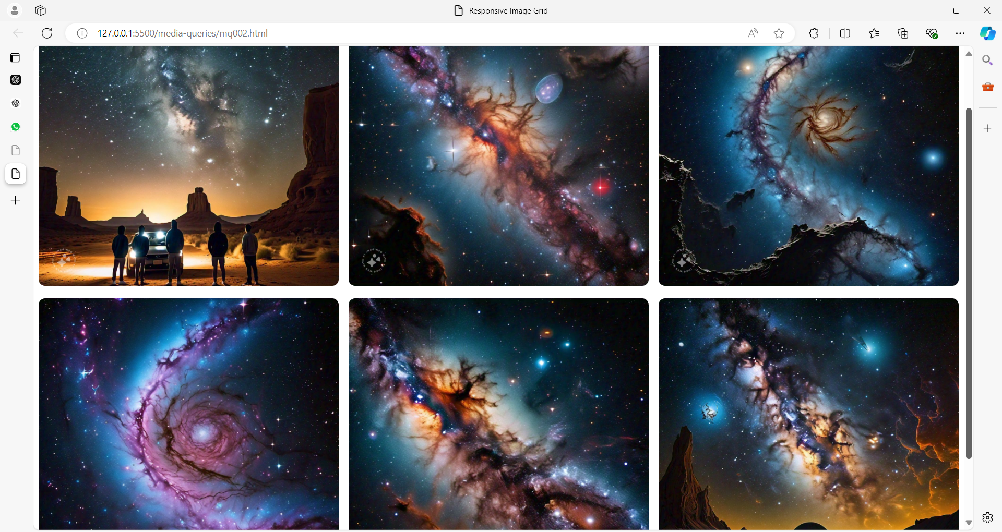

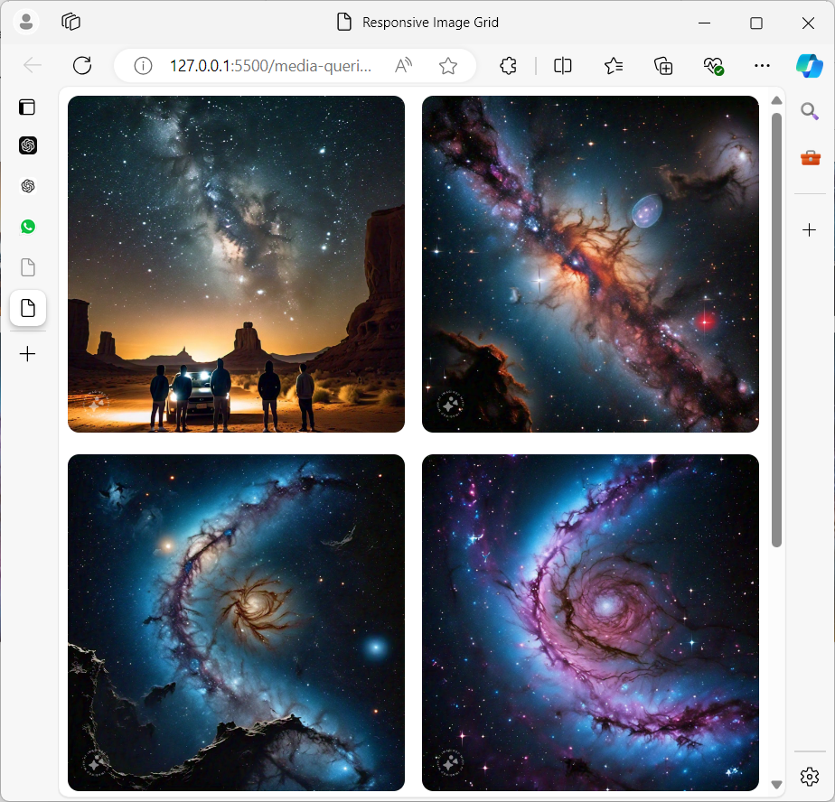

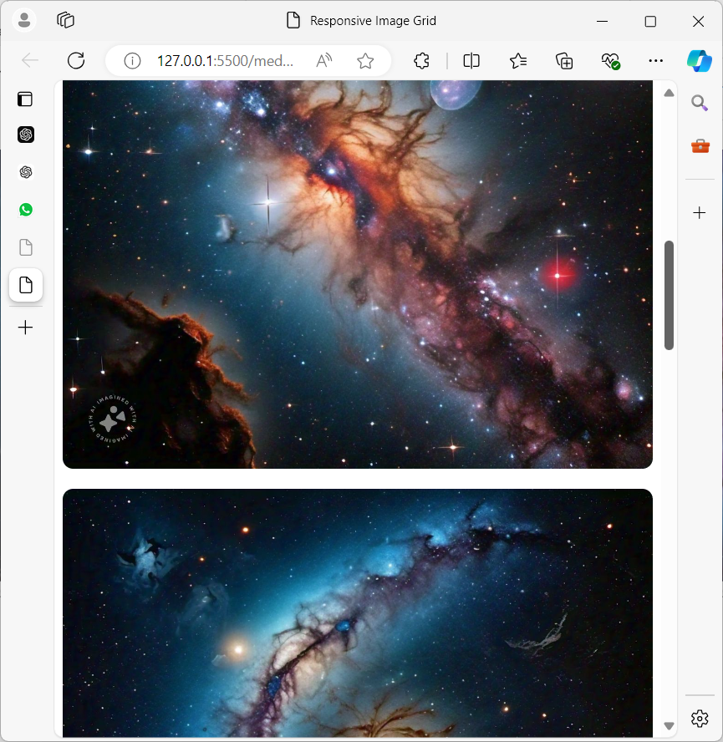

**HTML and CSS Example:**

<!DOCTYPE html>

<html lang="en">

<head>

    <meta charset="UTF-8">

    <meta name="viewport" content="width=device-width, initial-scale=1.0">

    <title>Responsive Image Grid</title>

    <style>

        .gallery {

            display: grid;

            grid-template-columns: repeat(3, 1fr);

            gap: 15px;

        }

        @media (max-width: 1024px) {

            .gallery {

                grid-template-columns: repeat(2, 1fr);

            }

        }

        @media (max-width: 600px) {

            .gallery {

                grid-template-columns: 1fr;

            }

        }

        .gallery img {

            width: 100%;

            height: auto;

            border-radius: 10px;

            object-fit: cover;

        }

        .gallery-item {

            overflow: hidden;

        }

    </style>

</head>

<body>

    <div class="gallery">

        <div class="gallery-item">

            <img src="../images/milky01.jpg" alt="Image 1">

        </div>

        <div class="gallery-item">

            <img src="../images/milky02.jpg" alt="Image 2">

        </div>

        <div class="gallery-item">

            <img src="../images/milky03.jpg" alt="Image 3">

        </div>

        <div class="gallery-item">

            <img src="../images/milky04.jpg" alt="Image 4">

        </div>

        <div class="gallery-item">

            <img src="../images/milky05.jpg" alt="Image 5">

        </div>

        <div class="gallery-item">

            <img src="../images/milky06.jpg" alt="Image 6">

        </div>

    </div>

</body>

</html>

**Explanation:**

**HTML Structure:**

* **<div class="gallery">**: This is the parent container that holds all the images (items) in the grid.
* **<div class="gallery-item">**: Each image is wrapped inside a gallery-item div, which contains an image (<img> element).

**CSS Breakdown:**

1. **Grid Setup:**

**.gallery {**

**display: grid;**

**grid-template-columns: repeat(3, 1fr);**

**gap: 15px;**

**}**

* + The .gallery container is displayed as a grid with 3 equal columns.
  + gap: 15px; creates space between the grid items.

1. **Media Queries for Responsive Layout:**
   * For screens **1024px or smaller**:

**@media (max-width: 1024px) {**

**.gallery {**

**grid-template-columns: repeat(2, 1fr);**

**}**

**}**

The grid will reduce to 2 columns.

* + For screens **600px or smaller**:

**@media (max-width: 600px) {**

**.gallery {**

**grid-template-columns: 1fr;**

**}**

**}**

The grid becomes a single column, stacking all images vertically.

1. **Image Styling:**

**.gallery img {**

**width: 100%;**

**height: auto;**

**border-radius: 10px;**

**object-fit: cover;**

**}**

**.gallery-item {**

**overflow: hidden;**

**}**

* + width: 100%; ensures the image takes up the full width of its container.
  + height: auto; maintains the aspect ratio of the image.
  + border-radius: 10px; adds rounded corners to the images.
  + object-fit: cover; ensures that images are scaled nicely and fill the available space without distorting.

**Result:**

* On large screens (wider than 1024px), the grid will show 3 images per row.
* On medium screens (between 600px and 1024px), the grid will adjust to 2 images per row.
* On small screens (below 600px), the images will be displayed in a single-column layout.

This example is useful for creating responsive **image galleries** or portfolios that adapt to different screen sizes.

Media queries are a powerful tool in CSS that help create responsive designs, ensuring web pages look and function well on a wide range of devices and screen sizes.

**Fluid Layouts**

Fluid layouts, also known as liquid layouts, in CSS refer to web page designs where elements use relative units, such as percentages, to adapt and scale according to the user's screen size.

Unlike fixed layouts, which use fixed-width units like pixels, fluid layouts are more flexible and responsive, ensuring that content adjusts seamlessly across various screen sizes and devices.

**Key Characteristics of Fluid Layouts**

1. **Relative Units**
   * **Percentages**: Widths and other dimensions are often defined in percentages.
   * **Examples**: width: 50%, padding: 10%.
2. **Proportional Scaling**
   * Elements scale proportionally to the parent container or viewport.
   * Ensures a consistent look regardless of screen size.
3. **Flexibility**
   * Fluid layouts adapt to changes in screen size, providing a better user experience across different devices.
   * No need for horizontal scrolling on smaller screens.

**Example of a Fluid Layout**

Here's a simple example of a fluid layout using CSS:

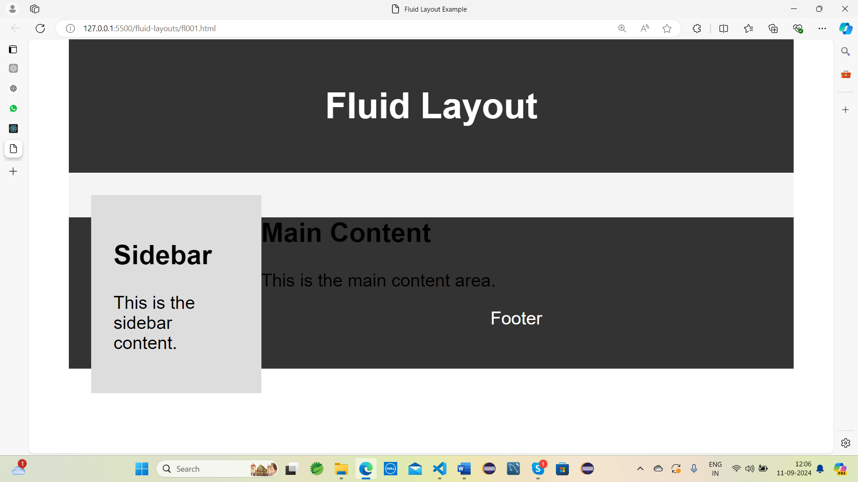

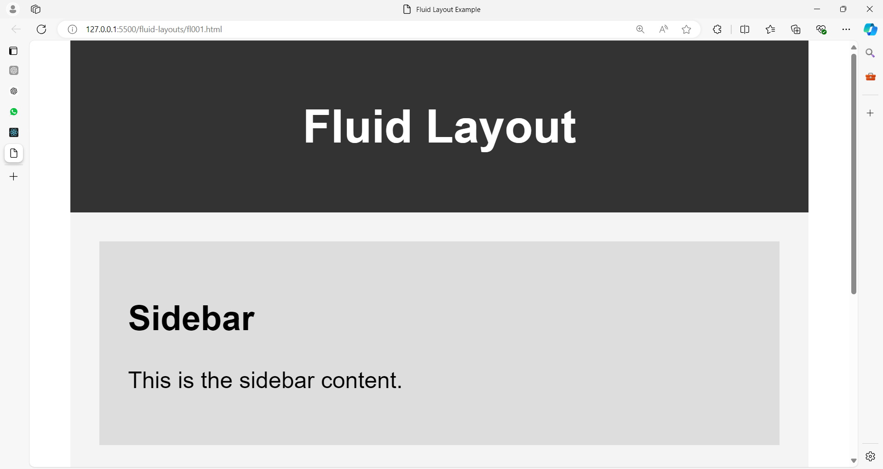

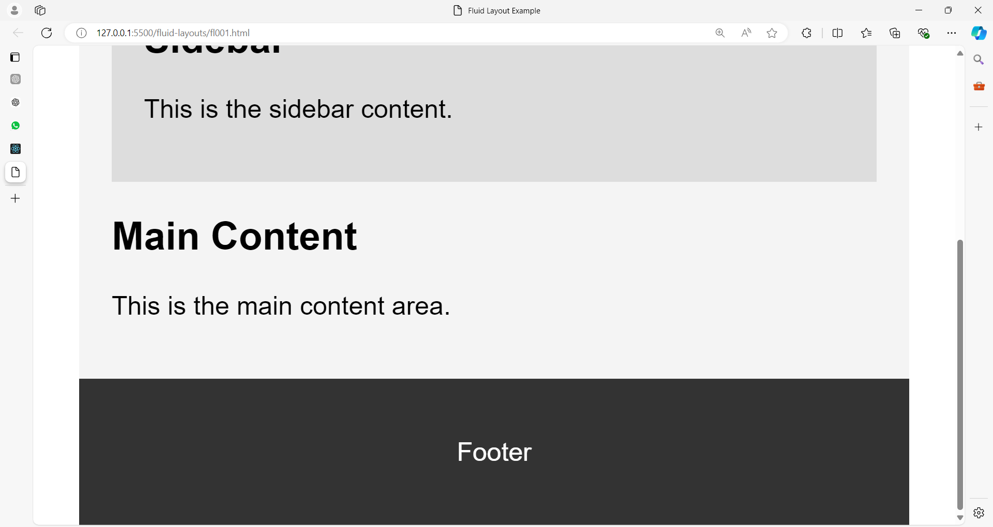

<!DOCTYPE html>

<html lang="en">

<head>

<meta charset="UTF-8">

<meta name="viewport" content="width=device-width, initial-scale=1.0">

<title>Fluid Layout Example</title>

<style>

body {

font-family: Arial, sans-serif;

margin: 0;

padding: 0;

}

.container {

width: 90%; /* Fluid width, taking up 90% of the viewport width */

margin: 0 auto; /* Center the container */

}

.header, .footer {

background-color: #333;

color: white;

padding: 20px; /* Padding for space inside the element */

text-align: center;

}

.main {

background-color: #f4f4f4;

padding: 20px; /* Padding for space inside the element */

}

.sidebar {

background-color: #ddd;

padding: 20px; /* Padding for space inside the element */

float: left; /* Float sidebar to the left */

width: 25%; /* Fluid width, taking up 25% of the container's width */

box-sizing: border-box; /* Include padding and border in the element's total width */

}

.content {

float: left; /* Float content to the left */

width: 75%; /* Fluid width, taking up 75% of the container's width */

box-sizing: border-box; /* Include padding and border in the element's total width */

}

@media (max-width: 600px) {

.sidebar, .content {

float: none; /* Remove float on smaller screens */

width: 100%; /* Full width for both sidebar and content */

}

}

</style>

</head>

<body>

<div class="container">

<div class="header">

<h1>Fluid Layout</h1>

</div>

<div class="main">

<div class="sidebar">

<h2>Sidebar</h2>

<p>This is the sidebar content.</p>

</div>

<div class="content">

<h2>Main Content</h2>

<p>This is the main content area.</p>

</div>

</div>

<div class="footer">

<p>Footer</p>

</div>

</div>

</body>

</html>

**Explanation**

1. **Container Width**
   * The .container class is given a width of 90%, allowing it to scale with the viewport.
2. **Responsive Sidebar and Content**
   * .sidebar and .content are given widths of 25% and 75%, respectively. This ensures they take up the respective portions of the container's width.
   * float: left is used to place them side by side.
   * box-sizing: border-box ensures that padding is included in the element's total width, preventing overflow.
3. **Media Query for Smaller Screens**
   * When the viewport width is 600px or less, the .sidebar and .content elements are set to width: 100% and float: none, making them stack vertically instead of horizontally.

**Benefits of Fluid Layouts**

1. **Adaptability**
   * Fluid layouts adapt to various screen sizes without needing multiple fixed-width breakpoints.
2. **User Experience**
   * Provides a consistent and comfortable viewing experience across different devices, reducing the need for horizontal scrolling.
3. **Future-Proofing**
   * Fluid layouts are more likely to remain usable as new devices with different screen sizes and resolutions are introduced.

Fluid layouts are a crucial aspect of responsive design, ensuring that web content is accessible and visually appealing on a wide range of devices. By using relative units and flexible designs, fluid layouts help create a seamless user experience.